Ecological Keystone Network

Main disaster - Wildfire, Tornado, Heat waves, Flood, Earthquake, Eruptions, Smokes, Cold waves, Landslides, Hazardous waste

Ecology Keystone Network is a software that informs people on localized concurrent natural disasters and global ecological disasters.

We have two primary goals with our project. The first is to be able to inform people about localized concurrent natural disasters near them and precautionary guidelines they can take to establish their safety. The second is to be able to inform people about various ecological disasters affecting the globe and how they can learn more.

Our project is a full-stack web application that runs on Netlify. You traverse a 2d map of your local area or across the globe and can click on certain keystones to learn more about them. These keystones are concurrent natural disasters in your local area and/or ecological disasters across the globe. By clicking these keystones, you are informed about the type of event it is, its date of origin, its region of impact, as well as additional information and safety guidelines from an embedded hyperlink.

For both keystone types, concurrent natural disasters and ecological disasters, we have an automated system that scrapes the internet and government databases for keywords, phrases, and location matching to identify and publicize these natural and ecological disasters as unverified keystones. We then have a small team verify the legitimacy of the event and its details before we officially verify it as a keystone on our map. With localized concurrent natural disasters specifically, we also (insert terminology for pulling info from new stations here) from local news stations and online sources in the area of the reported concurrent disaster. We chose this method because we figured that the speed at which disasters are reported are fastest when done by local observers and new stations assigned to particular regions of geography. Our keystones update as information from our **vessels** updates. Once the natural disaster passes, we store its information in our history of previous natural disasters in that localized area and remove its keystone from the 2d map.

Some different features that we have implemented and/or are attempting to implement are the following. A search option that allows you to filter for certain characteristics such as wildfire disasters, floods, localized disasters, or global ecological disasters. A proactive tool that tracks your localized location and creates a “disaster bubble” around you to specifically highlight and inform you of specific hazards to avoid. A connectivity feature that when you hover over a particular type of natural or ecological disaster, other disasters of that type are also highlighted on the map to showcase similar areas of impact. An extension tool that allows you to look over an area's preexisting history of natural and/or ecological disasters. A broadcast system that allows you to watch new reports as they happen live through our application regarding concurrent natural disasters.

**Washington**

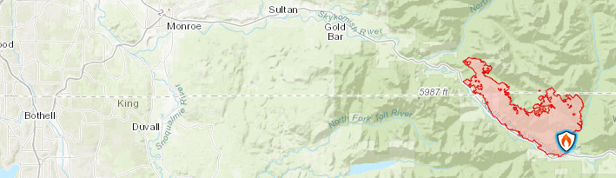

Event: Wildfire

Date of Origin: September 10th, 2022

Location: Skykomish, Washington

Guidelines:

* Gather food, water, and medicine in advance because stores and pharmacies might be closed.
* Go-Kit: 3 days of supplies that you can easily carry with you.
* Stay-at-Home Kit: 2 weeks of supplies if you need to stay at home.
* Have a 1-month supply of medication in a child-proof container.
* Keep personal, financial, and medical records safe.
* Organization that fights wildfire: https://www.redcross.org/donate/donation.html/

Info on guidelines are found here:

<https://www.redcross.org/get-help/how-to-prepare-for-emergencies/types-of-emergencies/wildfire.html>

**Washington**

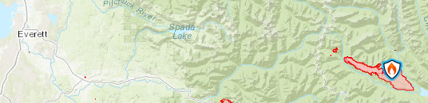

Event: Wildfire

Date of Origin: August 11th, 2022

Location: Plain, Washington

Guidelines:

* Gather food, water, and medicine in advance because stores and pharmacies might be closed.
* Go-Kit: 3 days of supplies that you can easily carry with you.
* Stay-at-Home Kit: 2 weeks of supplies if you need to stay at home.
* Have a 1-month supply of medication in a child-proof container.
* Keep personal, financial, and medical records safe.
* Organization that fight wildfires: https://www.redcross.org/donate/donation.html/

Info on guidelines are found here:

<https://www.redcross.org/get-help/how-to-prepare-for-emergencies/types-of-emergencies/wildfire.html>

**Washington**

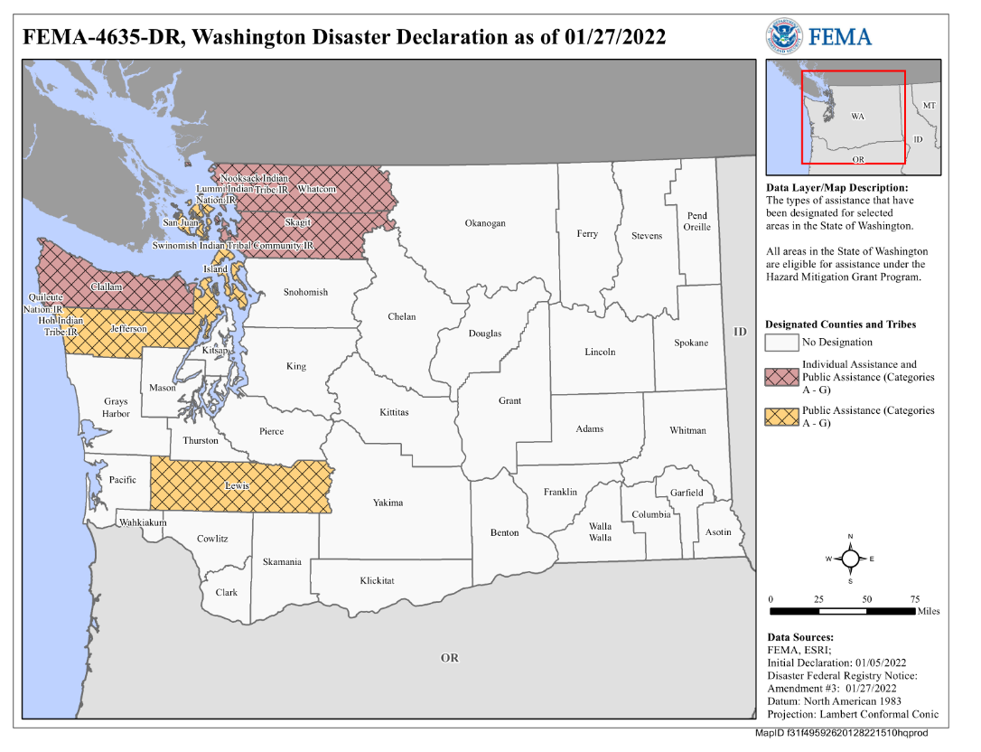

Event: Flooding and Mudslides

Date of Origin: November 13th, 2021

Location: Multiple areas (we can write this or list all locations?)

Guidelines:

* Evacuate immediately, if told to evacuate. Never drive around barricades. Local responders use them to safely direct traffic out of flooded areas.
* Contact your healthcare provider If you are sick and need medical attention. Wait for further care instructions and shelter in place, if possible. If you are experiencing a medical emergency, call 9-1-1.
* Listen to EAS, NOAA Weather Radio or local alerting systems for current emergency information and instructions regarding flooding.
* Do not walk, swim or drive through flood waters. Turn Around. Don’t Drown!
* Stay off bridges over fast-moving water. Fast-moving water can wash bridges away without warning.
* Stay inside your car if it is trapped in rapidly moving water. Get on the roof if water is rising inside the car.
* Get to the highest level if trapped in a building. Only get on the roof if necessary and once there signal for help. Do not climb into a closed attic to avoid getting trapped by rising floodwater.
* Organization that fight floods: https://www.ready.gov/get-involved

Info on guidelines are found here:

https://www.ready.gov/floods

Info on the event are found here:

<https://www.fema.gov/disaster/4635>

**Alaska**

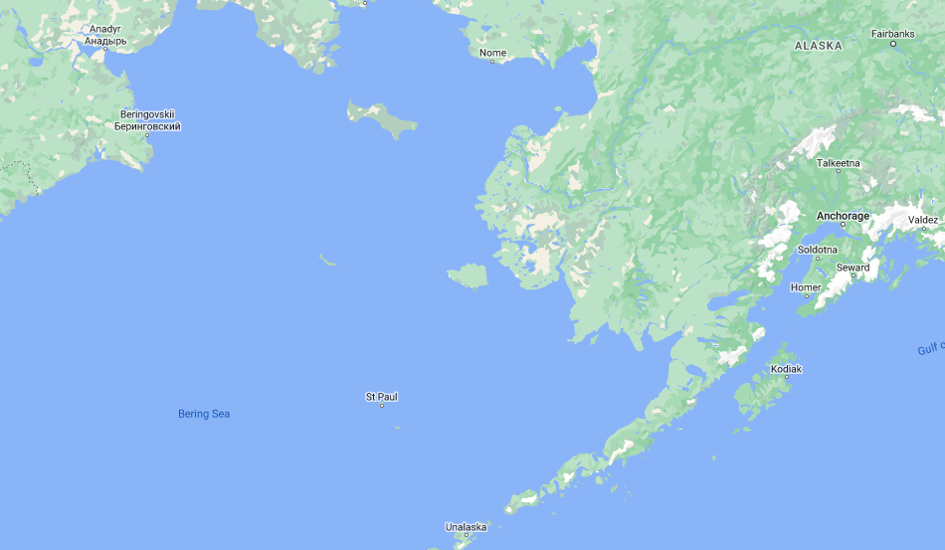

Event: Snow crab population decrease

Date of Origin: 2018 (no date? What we do)

Location: Bering Sea, Alaska (how we format this)

Guidelines:

(not sure guidelines for crabs other than stop global warming but thats a little off track, and theres no like donation links to help)

Info on guidelines are found here:

Info on the event are found here:

<https://www.theguardian.com/environment/2022/oct/20/billions-gone-whats-behind-the-disappearance-of-alaska-snow-crabs#:~:text=The%20situation%20continued%20into%202022,in%202018%2C%20to%201.9%20billion>.

**Kentucky, Illinois, Tennessee, Missouri, Arkansas**

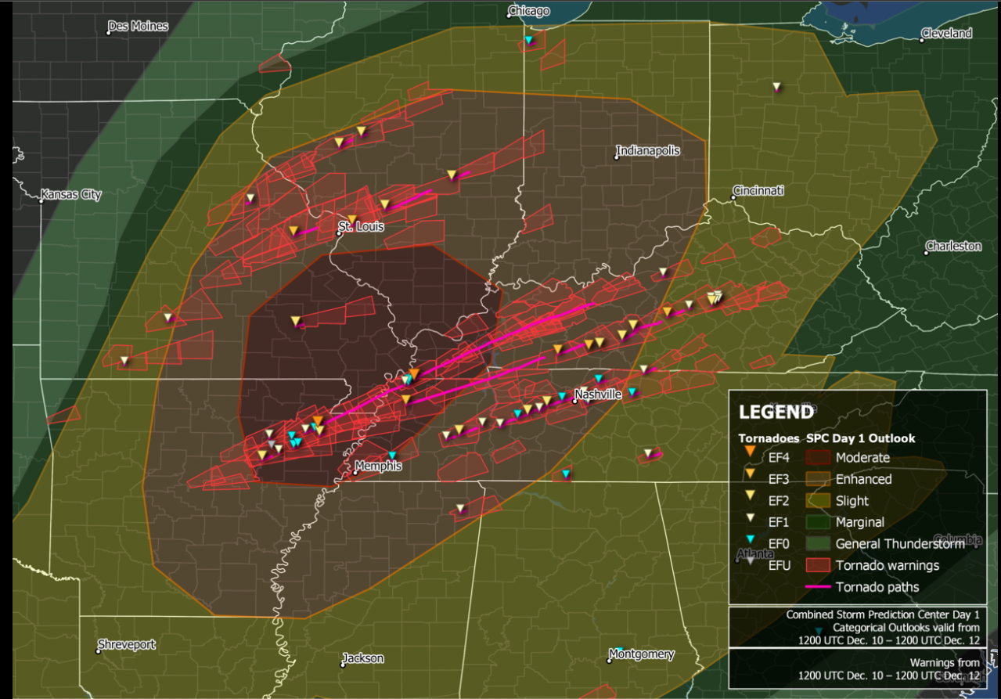

Event: Tornado

Date of Origin: December 10th, 2021

Location: Multiple areas (we can write this or list all locations?) (we need specific locations)

Guidelines:

* Go to the basement or an inside room without windows on the lowest floor (bathroom, closet, center hallway).
* If possible, avoid sheltering in any room with windows.
* For added protection get under something sturdy (a heavy table or workbench). Cover your body with a blanket, sleeping bag or mattress. Protect your head with anything available.
* Do not stay in a mobile home.
* Organization that fight tornados: https://www.redcross.org/donate/donation.html/

Info on guidelines are found here:

https://www.cdc.gov/nceh/features/tornadosafety/index.html#:~:text=Go%20to%20the%20basement%20or,blanket%2C%20sleeping%20bag%20or%20mattress.

Info on the event are found here:

<https://en.wikipedia.org/wiki/List_of_natural_disasters_in_the_United_States>